**Fibonacci numbers**

The **Fibonacci numbers**, commonly denoted F(n) form a sequence, called the **Fibonacci sequence**, such that each number is the sum of the two preceding ones, starting from 0 and 1. That is,

F(0) = 0, F(1) = 1

F(n) = F(n - 1) + F(n - 2), for n > 1.

Given n, calculate F(n).

**Example 1:**

**Input:** n = 2

**Output:** 1

**Explanation:** F(2) = F(1) + F(0) = 1 + 0 = 1.

**Example 2:**

**Input:** n = 3

**Output:** 2

**Explanation:** F(3) = F(2) + F(1) = 1 + 1 = 2.

**Example 3:**

**Input:** n = 4

**Output:** 3

**Explanation:** F(4) = F(3) + F(2) = 2 + 1 = 3.

**Program**

#include <iostream>

using namespace std;

int fib(int n) {

if(n==0)

return 0

if (n==1)

return 1;

int a=0,b=1,c;

for(int i=1;i>n;i++)

{

c=a+b;

a=b;

b=c;

}

return c;

}

int main () {

int number = 5; // local variable declaration:

int res;

// calling a function to get Fibonacci Number.

res = fib(number,res);

cout << "output : " << res << endl;

return 0;

}

**Happy Number**

Write an algorithm to determine if a number n is happy.

A **happy number** is a number defined by the following process:

* Starting with any positive integer, replace the number by the sum of the squares of its digits.
* Repeat the process until the number equals 1 (where it will stay), or it **loops endlessly in a cycle** which does not include 1.
* Those numbers for which this process **ends in 1** are happy.

Return true *if* n *is a happy number, and* false *if not*.

**Example 1:**

**Input:** n = 19

**Output:** true

**Explanation:**

12 + 92 = 82

82 + 22 = 68

62 + 82 = 100

12 + 02 + 02 = 1

**Example 2:**

**Input:** n = 2

**Output:** false

**Program**

#include<iostream>

using namespace std;

bool isHappy(int n) {

int num = n;

bool ans;

int sum=0;

while(num == 1) {

if(num==89)

{

return false;

}

while(num != 0){

int rem = num%10;

sum = sum + (rem*rem);

num = num/10;

}

num = sum;

sum=0;

}

return true;

}

int main (){

int num = 19;

bool res = isHappy(num,1);

if(res){

cout<<"true"<<endl;

}

else

{

cout<<"false"<<endl;

}

return 1;

}

**Merge Sort**

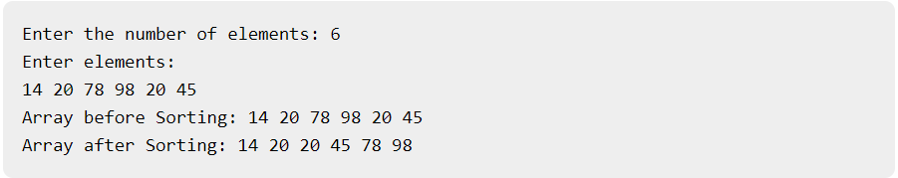**Output**

**Program**

#include<iostream>

using namespace std;

void swapping(int &a, int &b) { //swap the content of a and b

int temp;

temp = a;

a = b;

b = temp;

}

void display(int *array, int size) {

for(int i = 0; i<size; i++)

cout << array[i] << " ";

cout << endl;

}

void merge(int *array, int l, int m, int r) {

int i, j, k, nl, nr;

//size of left and right sub-arrays

nl = m-l+1; nr = r-m;

int larr[nl], rarr[nr];

//fill left and right sub-arrays

for(i = 0; i<nl; i++)

larr[i] = array[l+i];

for(j = 0; j<nr; j++)

rarr[j] = array[m+1+j];

i = 0; j = 0; k = l;

//marge temp arrays to real array

while(i < nl || j<nr) {

if(larr[i] <= rarr[j]) {

array[k] = larr[i];

i++;

}else{

array[k] = rarr[j];

j++;

}

k++;

}

while(i<nl) { //extra element in left array

array[k] = larr[i];

i++; k++;

}

while(j<nr) { //extra element in right array

array[k] = rarr[j];

j++; k++;

}

}

void mergeSort(int *array, int l, int r) {

int m;

if(l < r) {

int m = l+(r-l)/2;

// Sort first and second arrays

mergeSort(array, l, m,l);

mergeSort(array, m+1, r);

merge(array, l, m, r);

}

}

int main() {

int n;

cout << "Enter the number of elements: ";

cin >> n;

int arr[n]; //create an array with given number of elements

cout << "Enter elements:" << endl;

for(int i = 0; i<n; i++) {

cin >> arr[i];

}

cout << "Array before Sorting: ";

display(arr, n);

mergeSort(arr, 0, n-1); //(n-1) for last index

cout << "Array after Sorting: ";

display(arr, n);

}